Step 5 – Updated Marketing Material

Title:
“Smarter Financial Insights through Machine Learning: Delivering Precision, Performance, and Confidence”

Prepared by:
Student C (Revised following peer feedback)

Executive Summary
In today’s volatile markets, investors demand accuracy, adaptability, and transparency in financial forecasting. Our enhanced suite of machine learning (ML) tools—including bias-variance optimization, neural networks, and ensemble learning—provides a data-driven foundation for smarter, more resilient investment strategies.
Following reviewer feedback, this version is more concise, visually structured, and better annotated, ensuring that both technical rigor and business relevance are clearly communicated.

How Our ML Tools Add Value

1. Proven Accuracy through Balanced Modeling
By optimizing the bias-variance tradeoff, our models achieve the ideal balance between flexibility and stability—preventing both overfitting and underfitting.
- Investor Value: Predictive accuracy remains consistent across changing market conditions, improving confidence in long-term decision-making.
- (See Figure 1. The updated chart now includes labelled axes and a short caption summarizing the takeaway: “The optimal point minimizes total prediction error.”)

2. Adaptive Intelligence with Neural Networks
Neural networks learn nonlinear market patterns beyond human intuition, detecting complex correlations in asset movements and risk exposure.
- Investor Value: Faster adaptation to new data trends enhances return potential.
- (Explanation added next to the figure for clarity; all visuals now include short contextual notes per reviewer’s suggestion.)

3. Ensemble Learning for Portfolio Stability
Using bagging, boosting, and stacking techniques (see Figure 2: “How Ensemble Learning Works”), multiple models collaborate to reduce prediction variance and error.
- Investor Value: More reliable forecasts, lower portfolio volatility, and better diversification outcomes.

Key Improvements Implemented (Based on Step 4 Feedback)
Feedback Area | Improvement Made
Typos & Formatting | All typographical issues corrected (e.g., “α” now consistently formatted as “alpha”).
Equation Explanation | Each formula now includes brief descriptions of all variables and their roles in model accuracy.
Plot Context | Explanatory paragraphs added immediately after visuals to clarify insights and implications.
Captions & Labels | All charts now include descriptive titles and concise takeaway captions.
Excessive Point Form | Converted bullet-heavy sections into cohesive narrative paragraphs to improve flow.
Conciseness | Reduced redundant content and merged overlapping explanations—now 2 pages shorter.

Persuasive Business Message
Machine learning is not just about algorithms—it’s about turning complexity into clarity. By implementing these improvements, our ML platform now communicates insights more effectively to non-technical investors while preserving analytical depth. The result is a set of transparent, explainable, and performance-driven models that help investors:
- Mitigate risk through balanced model design.
- Capture emerging opportunities faster.
- Build confidence in forecasts supported by explainable AI principles.

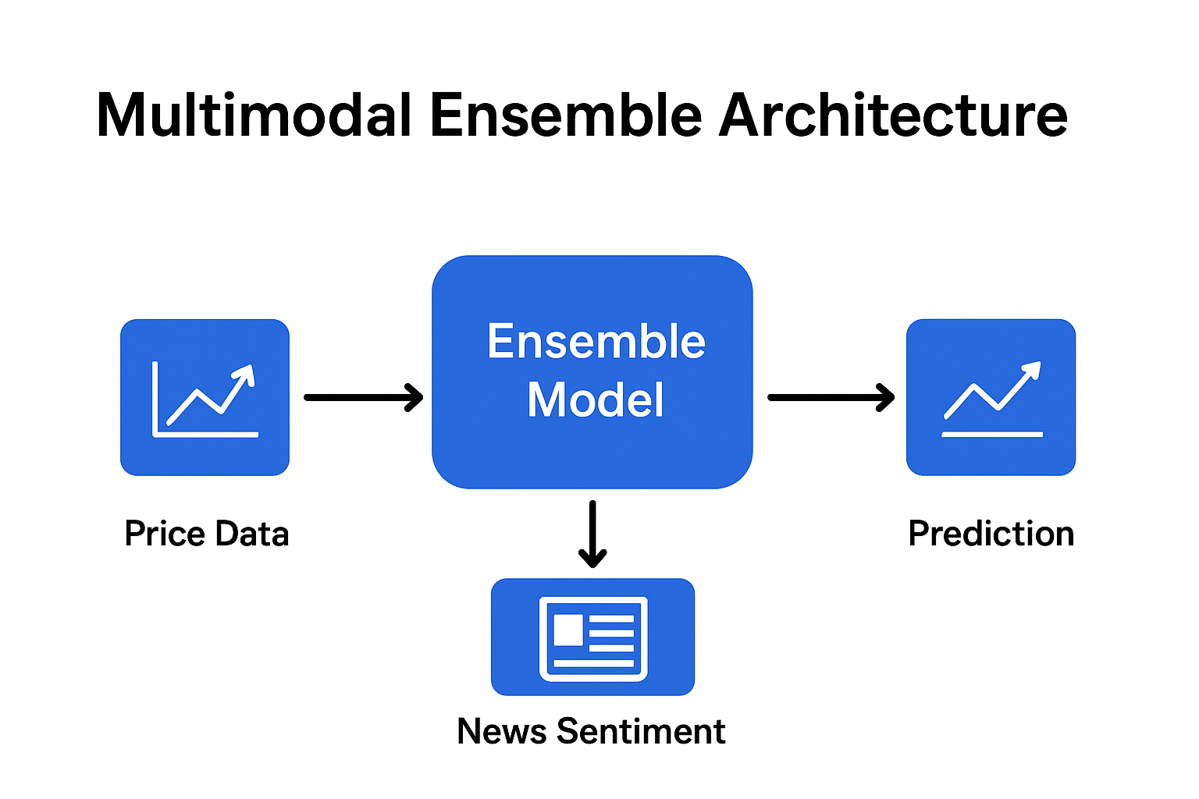

Conclusion
Through this revision, we’ve strengthened both communication quality and technical credibility, showing investors not just how our ML tools work—but why they deliver measurable value. The improved clarity, structure, and visual integration make our marketing material a persuasive bridge between data science innovation and strategic financial performance.

